SECTION A: Multiple-choice questions (1 mark each)
Question 1

Answer: D

Explanation:
This is an endothermic reaction. The energy required to break bonds is greater than the energy released when bonds form.

Question 2

Answer: C

Explanation:
These values can be read from the graph. Note: activation energies are never negative.

Question 3

Answer: B

Explanation:
The activation energy is lower as less energy is needed to heat the water to steam. This lowers ΔH, hence it lowers the activation energy. (Picture the impact on the reverse reaction to help visualise this question)

Question 4

Answer: C

Explanation:
1 mole of ethane produced 1560 kJ => 1 g = 1560/30 = 52 kJ
Be careful of units and sign in other options.

Question 5

Answer: A

Explanation:
The same amount of energy will cause a lower change in water. The ratio is 10x2.57/4.18 = 6.1 ⁰C

Question 6

Answer: B

Explanation:
0.05 mol of fuel produces 78 kJ => 1 mole produces 78/0.05 = 1560 kJ
Data book = ethane

Question 7

Answer: D

Explanation:
110 mL of oxygen requires 55 mL of nitrogen. Therefore nitrogen is the excess reagent with 25 mL unreacted. The volume of NO₂ = volume of O₂ = 110 mL

Question 8

Answer: A

Explanation:
110 mL of O₂ reacted at SLC = 0.110/24.8 = 0.0044 mol
The equation shows 2 mole of O₂ reacting requires 66.4 kJ => 1 mole requires 33.2 kJ
Energy required for 0.0044 mol = 0.0044 x 33.2 = 0.147 kJ = 147 J = 150 to 2 sig figs

Question 9

Answer: D

Explanation:
n(ethanol) = 0.46/46 = 0.01 mol
energy = 0.01 x 1367 = 13.67 kJ
ΔT should be energy/(4.18x250)= 13670/(4.18x250) = 13.1 ⁰C
Since the change is only 10, the %efficiency = 10x100/13.1 = 77%

Question 10

Answer: C

Explanation

1 g of each food supplies 37+17+16 = 70 kJ of energy.
210 kJ is therefore 3 g of each fuel => the food has a mass of 9 g

SECTION B: Short-answer questions

Question 1 (13 marks)
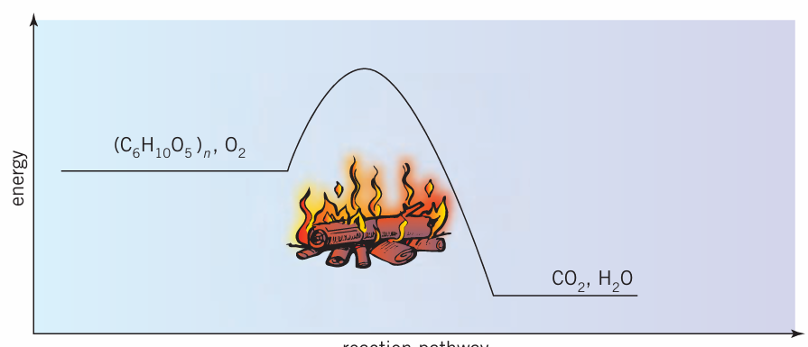
ΔH
activation energy
reaction progress

a. i. double covalent bonds in oxygen; then in wood, C-C, C-O, O-H and C-H bonds 2 marks

ii. O-H bonds in water and C=O double bonds in CO₂ 2 marks

iii. The energy required to break the bonds in wood will be less the energy released
when products form. This is evident as the reaction is exothermic. 2 marks

b. see diagram 2 marks

c. i. The composition of wood varies and includes a wide range of substances 1 mark

ii. Incomplete combustion of wood will produce CO instead of CO₂. Carbon monoxide is toxic and can cause deaths. Incomplete combustion in a a house is dangerous. 2 marks

iii. Wood is unlikely to be a helpful substitute. Combustion produces CO₂ and a range of other pollutants. The sourcing of timber to burn is likely to create as many issues as the sourcing of fossil fuels. Our forests have important roles to play. 2 marks

Question 2 (8 marks)
Methanol is commonly used as a fuel. It is a liquid at room temperature with a density of 0.78 g mL⁻¹.

a. 2CH₄O(g) + 3O₂(g) 2CO₂(g) + 4H₂O(g) ΔH = -1452 kJ 2 marks

b. i. 726 kJ mol⁻¹ (no negative sign as heat of combustion asked for) 1 mark

ii kJ g⁻¹ = 726/32 = 22.7 kJ g⁻¹ 1 mark

iii. mass of 1 L of methanol = 780 g
energy of 780 g = 780 x 22.7 =17,700 kJ L⁻¹ 2 marks

c. 1.0 GJ = 10⁹ J or 10⁶ kJ.
Mass methanol = 10⁶/22.7 = 44000 g = 44.0 kg 2 marks

Question 3 (10 marks)

a. 60 L of butane and 450 L of oxygen, both hat SLC, are reacted.

i. V(O₂) required = 60 x 13/2 = 390 L. Oxygen is in excess. 2 marks

ii. V(CO₂) = 4n(butane) = 240 L
V(H₂O) = 5n(butane) = 300 L Total 540 L 2 marks

iii. 60 L of O₂ remains = 60/24.8 mol = 2.42 mol
mass = 2.42 x 32 = 77 g 2 marks

b. i. n(butane) = 1000/58 = 17.2 mol
n(CO₂) = 17.2 x 4 = 69 mol
m = 69 x 44 = 3036 g = 3.0 kg 3 marks

ii. energy = 17.2 x 2880 = 50000 kJ 1 mark

Question 4 (9 marks)

a. temperature change = 31.1 = 19.6 = 11.5
energy = 4.18 x 140 x 11.5 = 6730 J
energy density = 6730/ 1.28 = 5.3 kJ g⁻¹ 3 marks

b. energy per serve = 15.6 x 16 + 2 x 17 + 5 x 37 = 468.6 kJ
energy per gram = 468.6/25 = 18.7 = 19 kJ g⁻¹ 2 marks

c. The experimental result is well below the theoretical result (only 30%). This is common in experiments involving combustion – the energy losses to the surroundings are very high. Discuss the difference between the values obtained in parts a. and b. 2 marks

d. The glass container could be replaced by a steel can. A lid could be used. The distance between the cracker and the container might be too great. The sides of the container could be insulated. 2 marks

